Using Vitis for a combine VHDL/C project
- Create Platform Project using exported hardware.
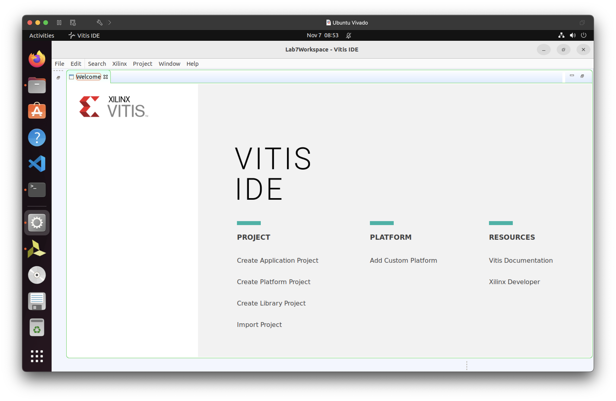
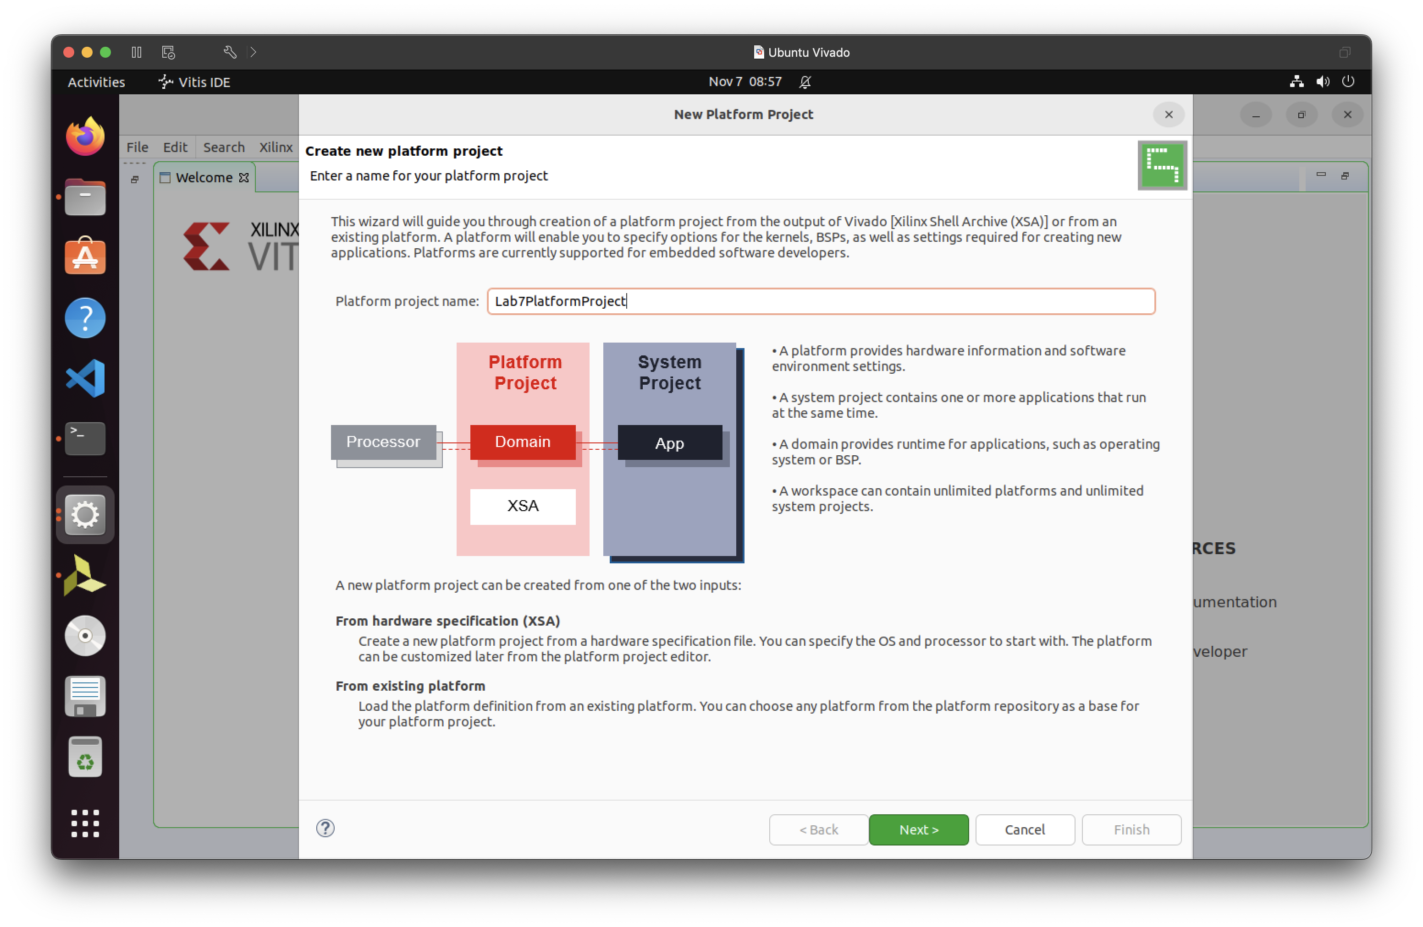

- Attach the .xsa file
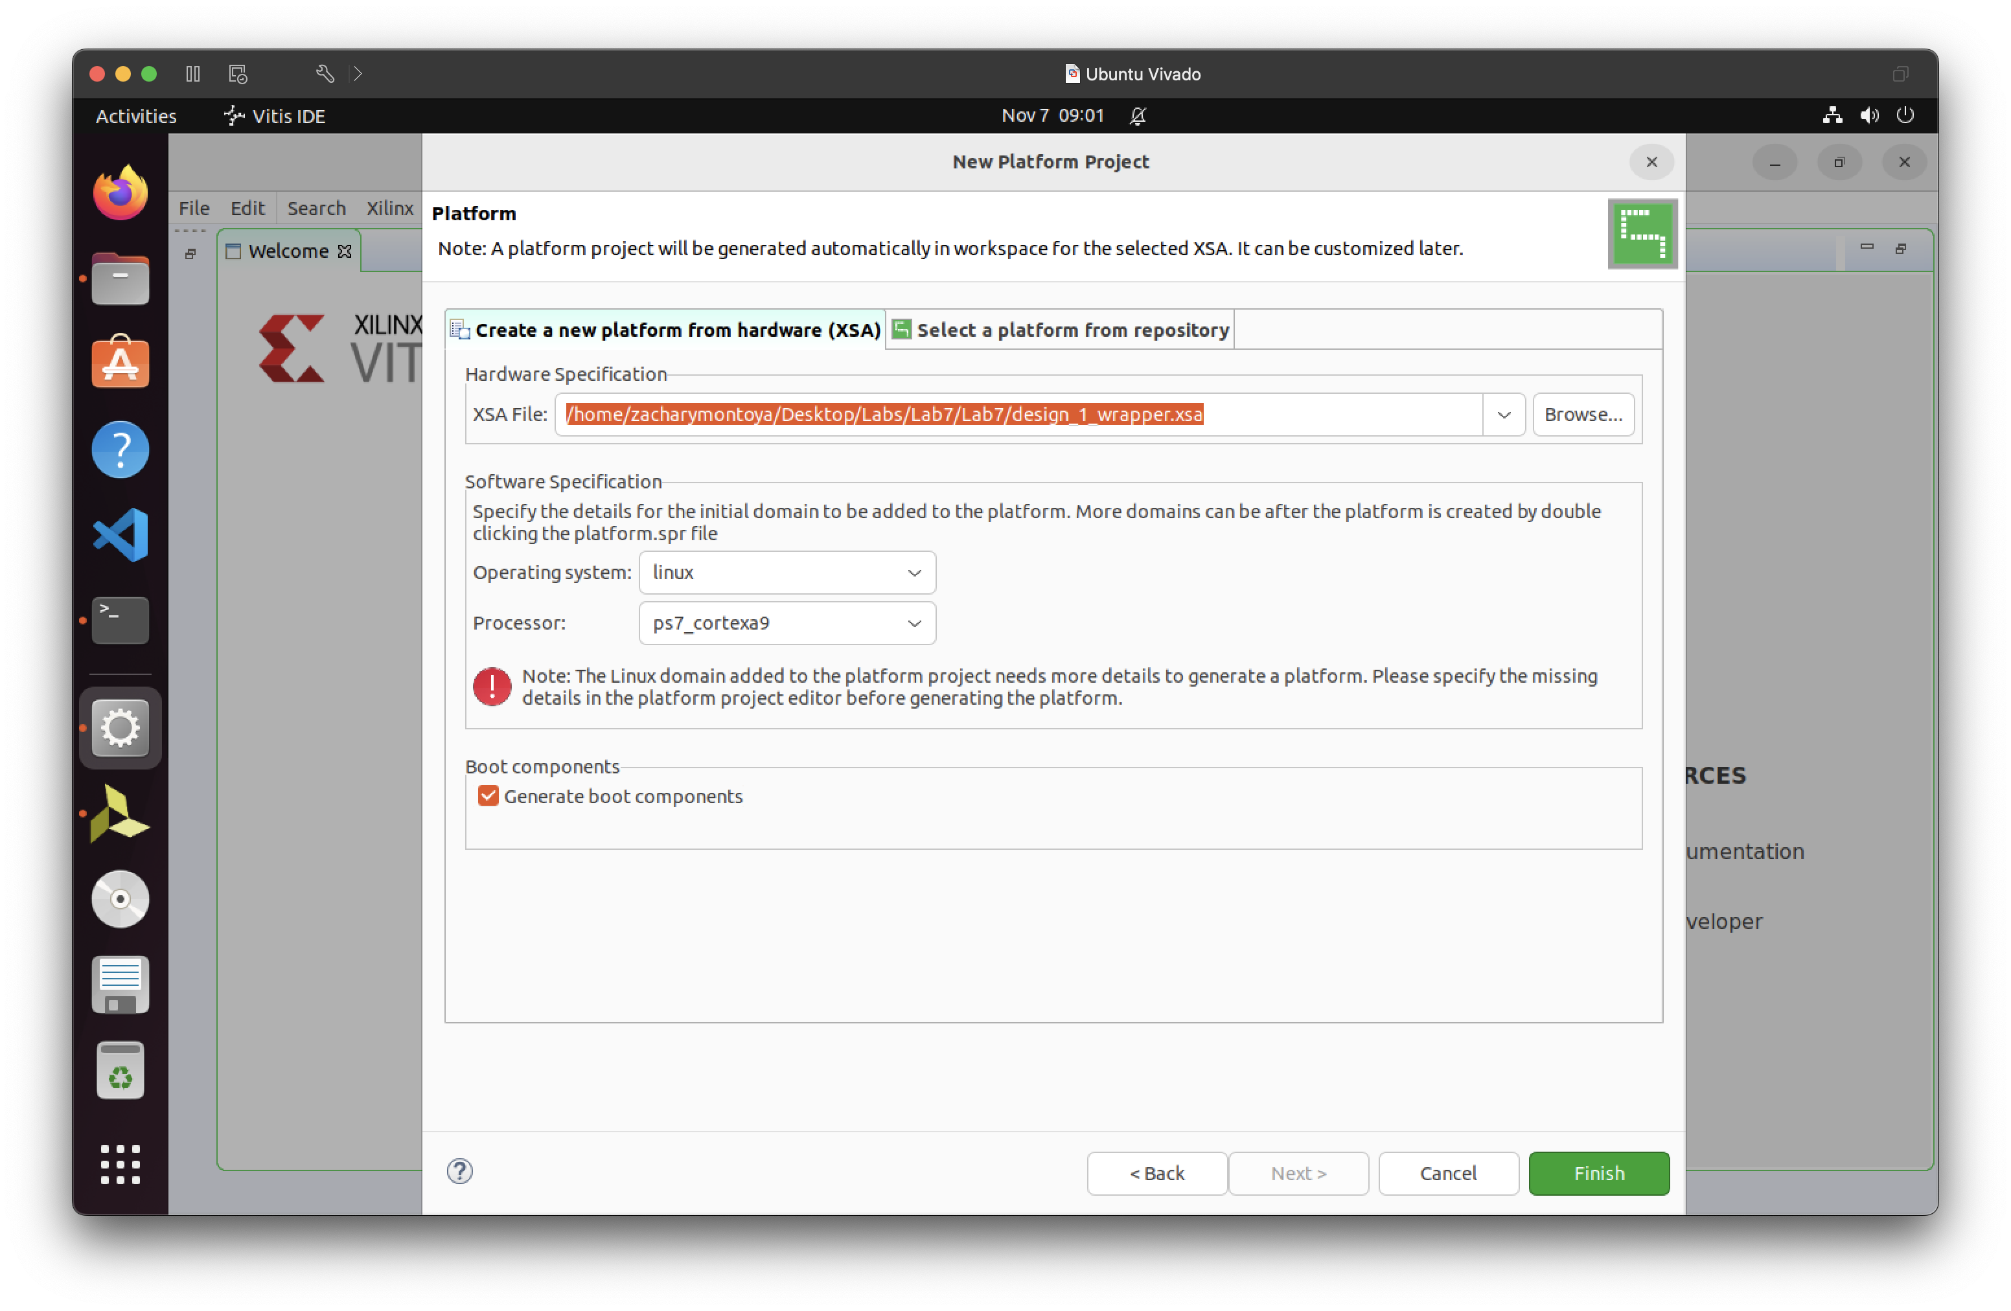
- Build the project.
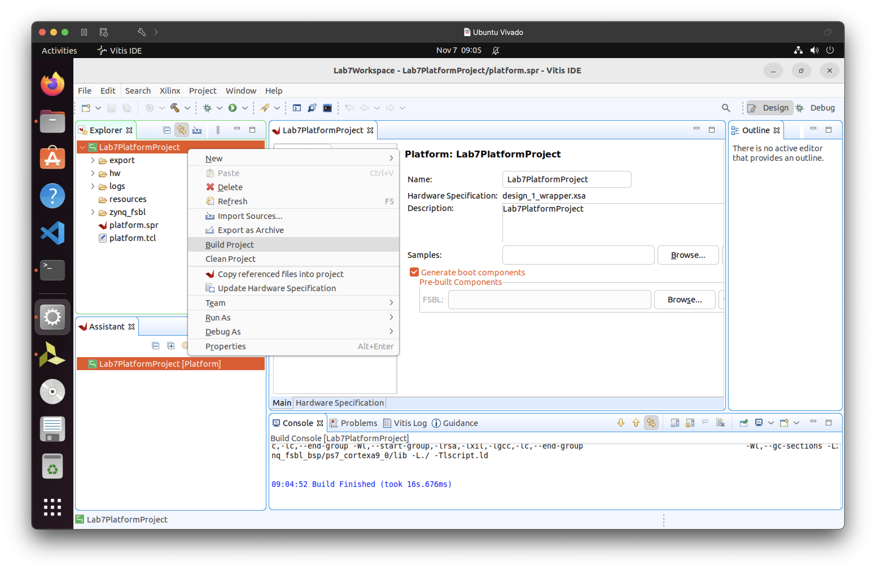

- Add the application project
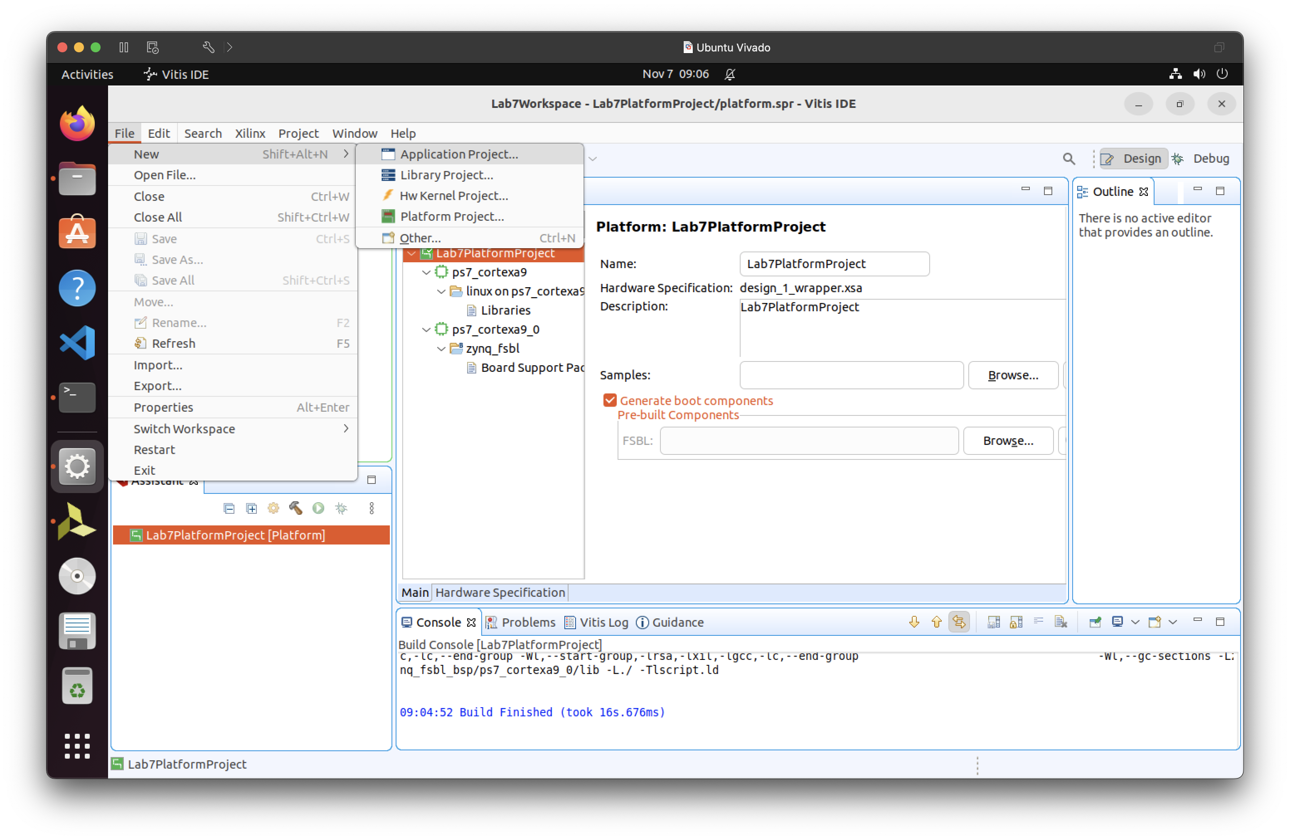
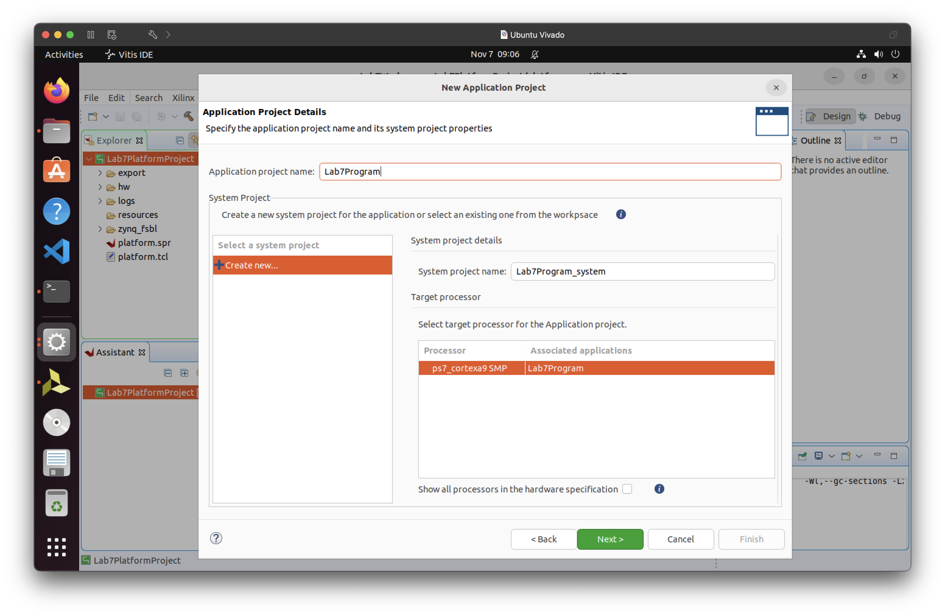

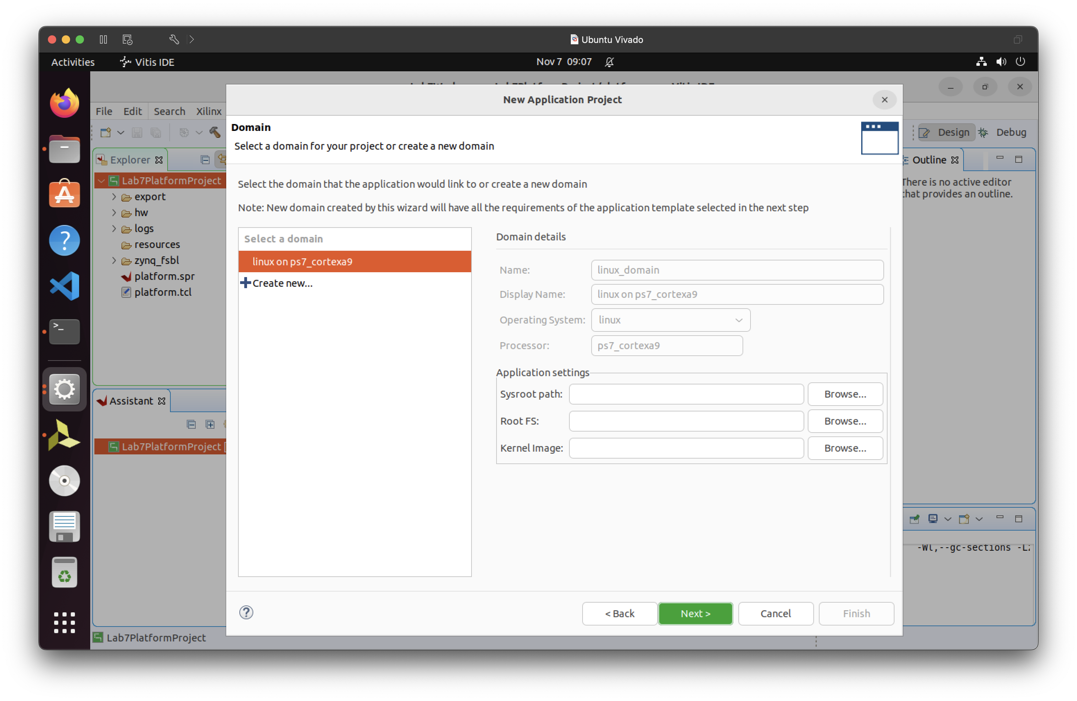
- Select an empty linux application
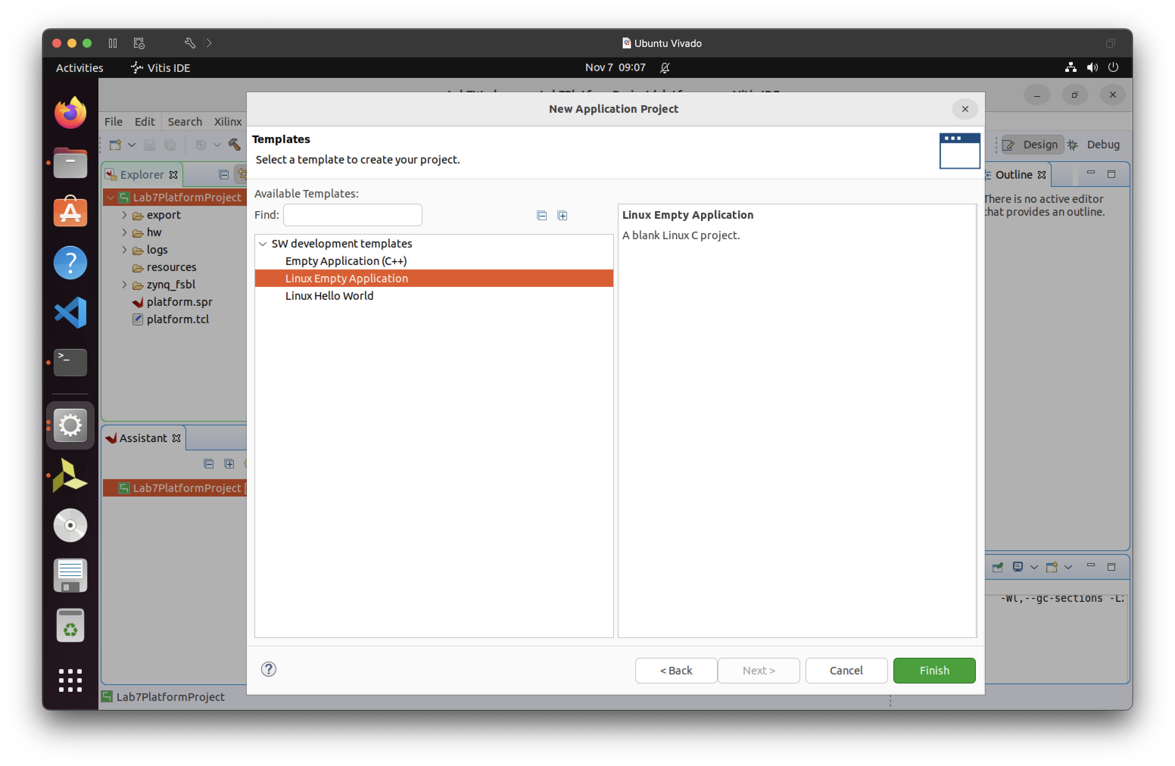

- Add a new file under the source code
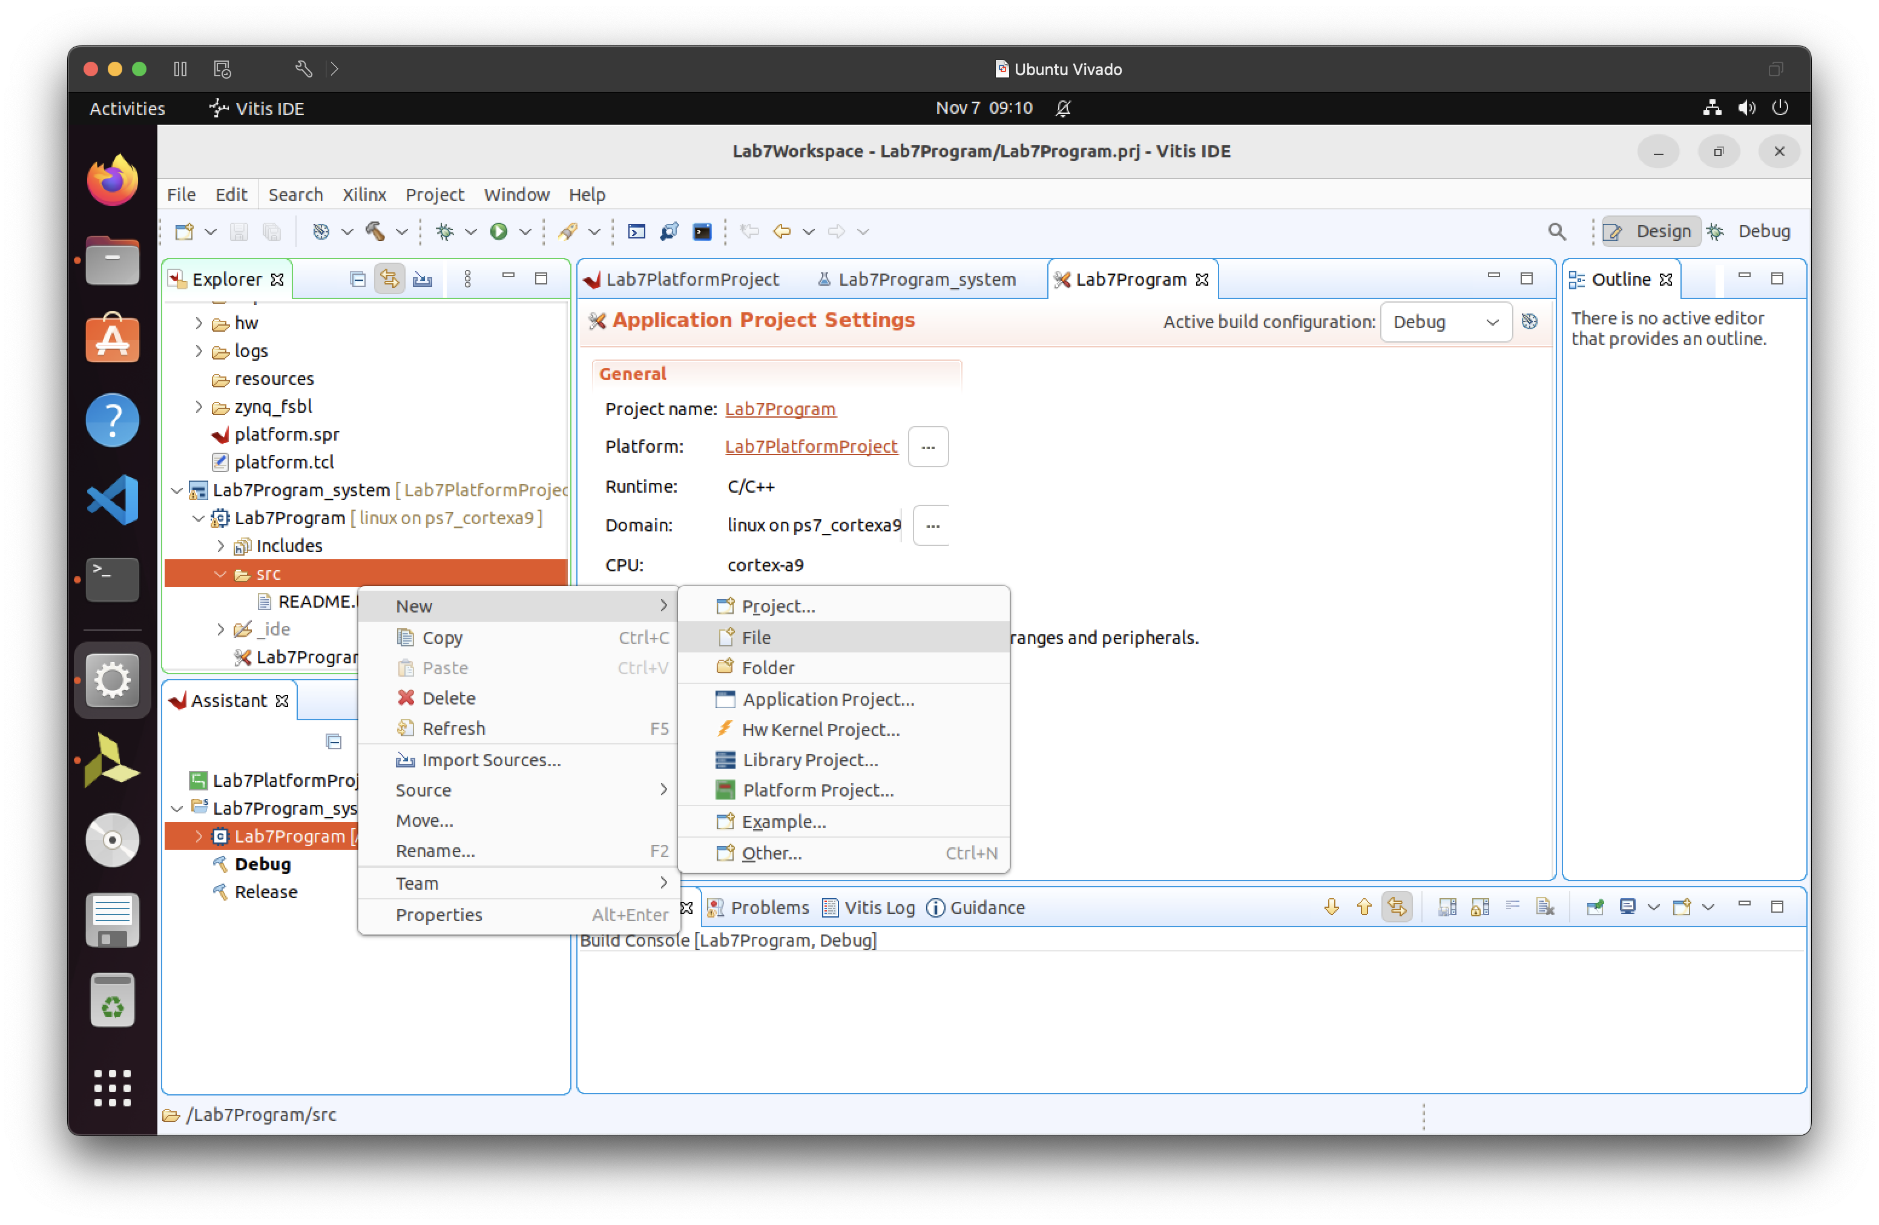
- Link to your .c file!!
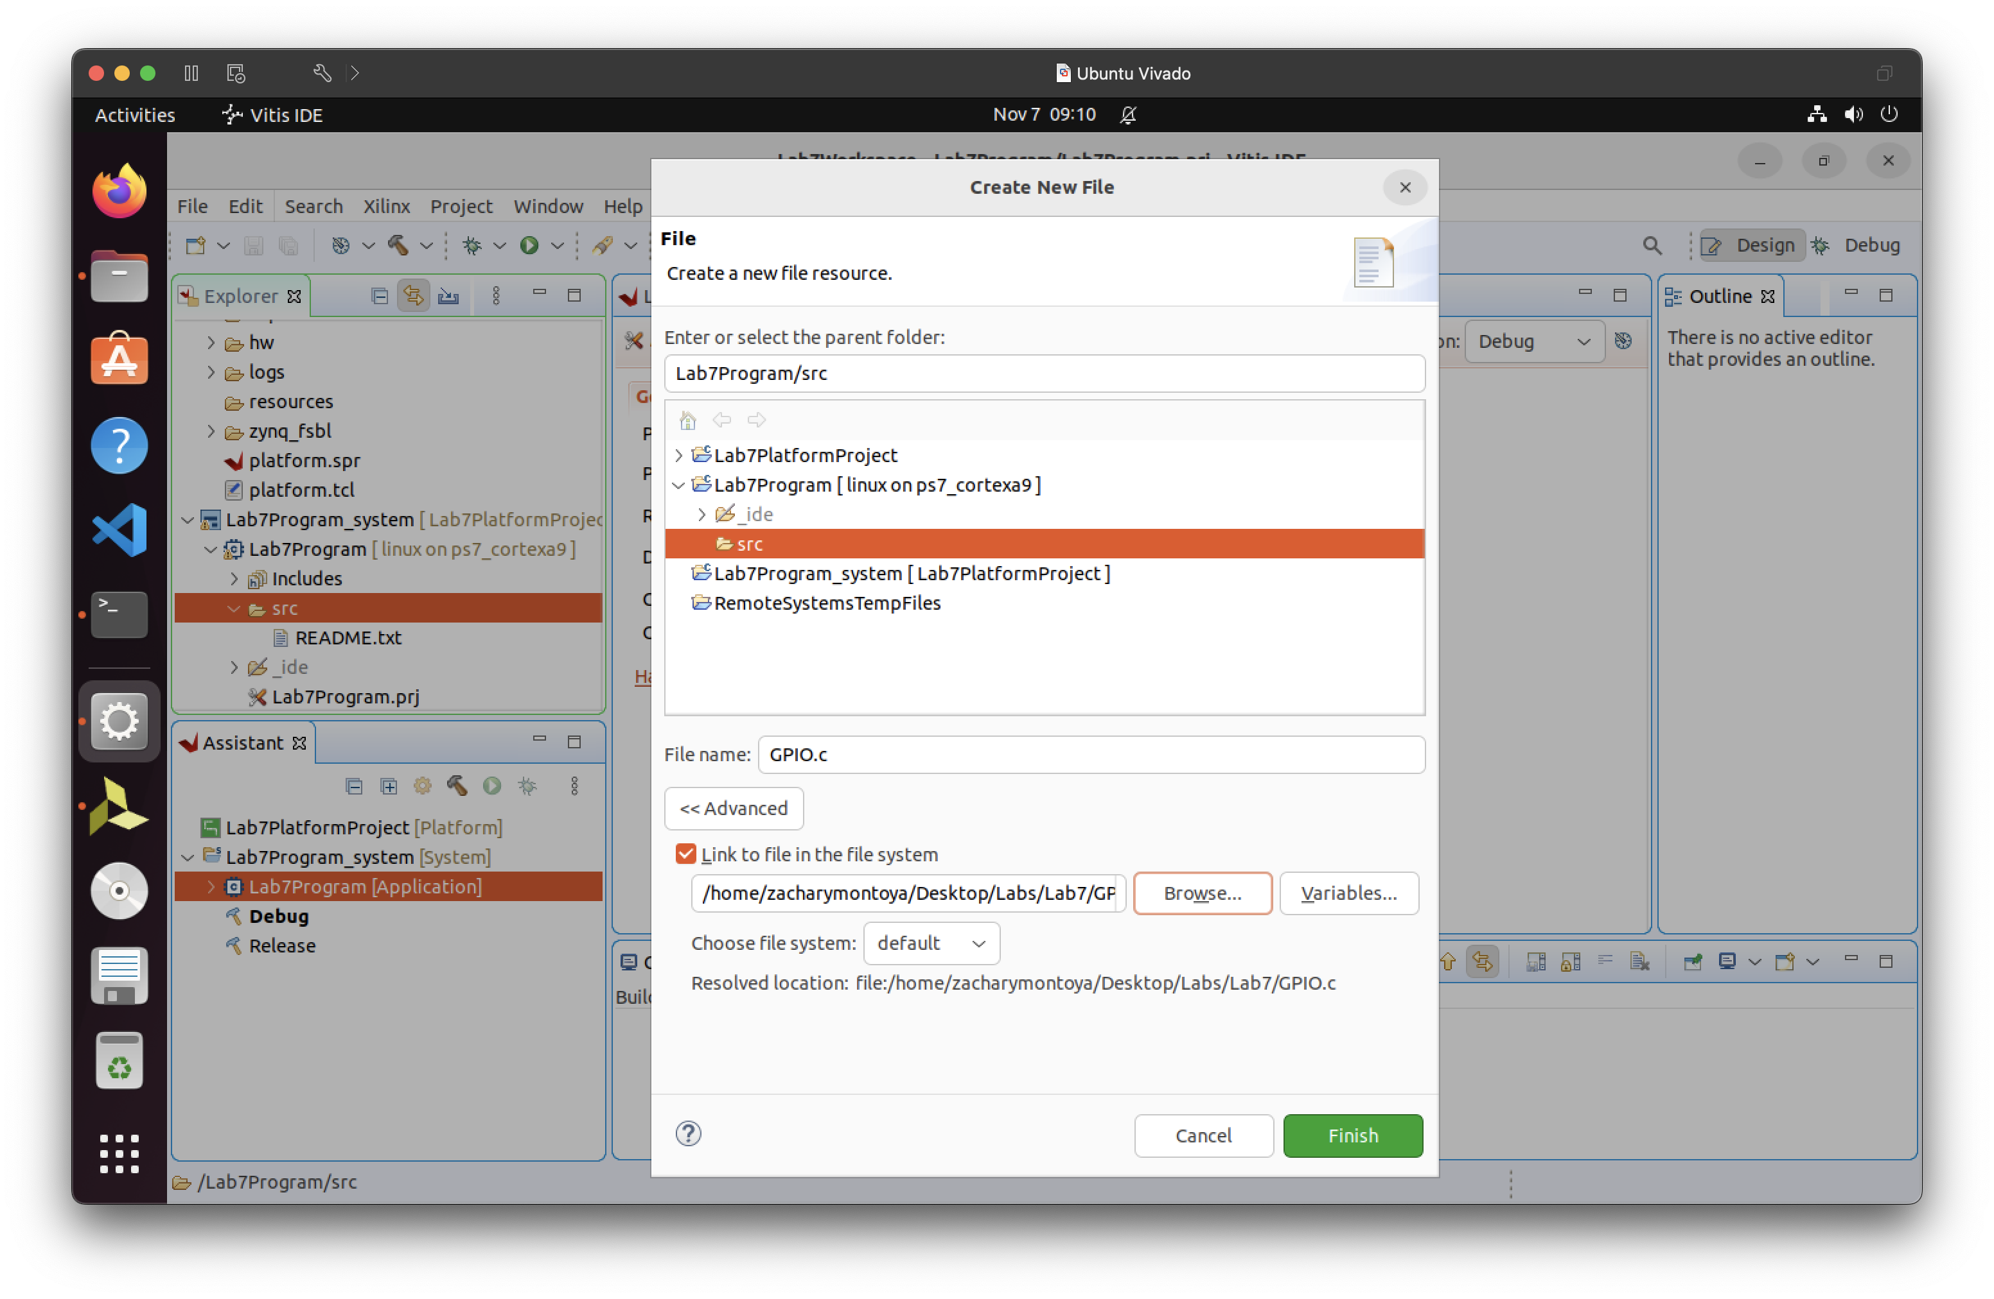

- Build (compile) the project. See the console below for gcc compiler info.
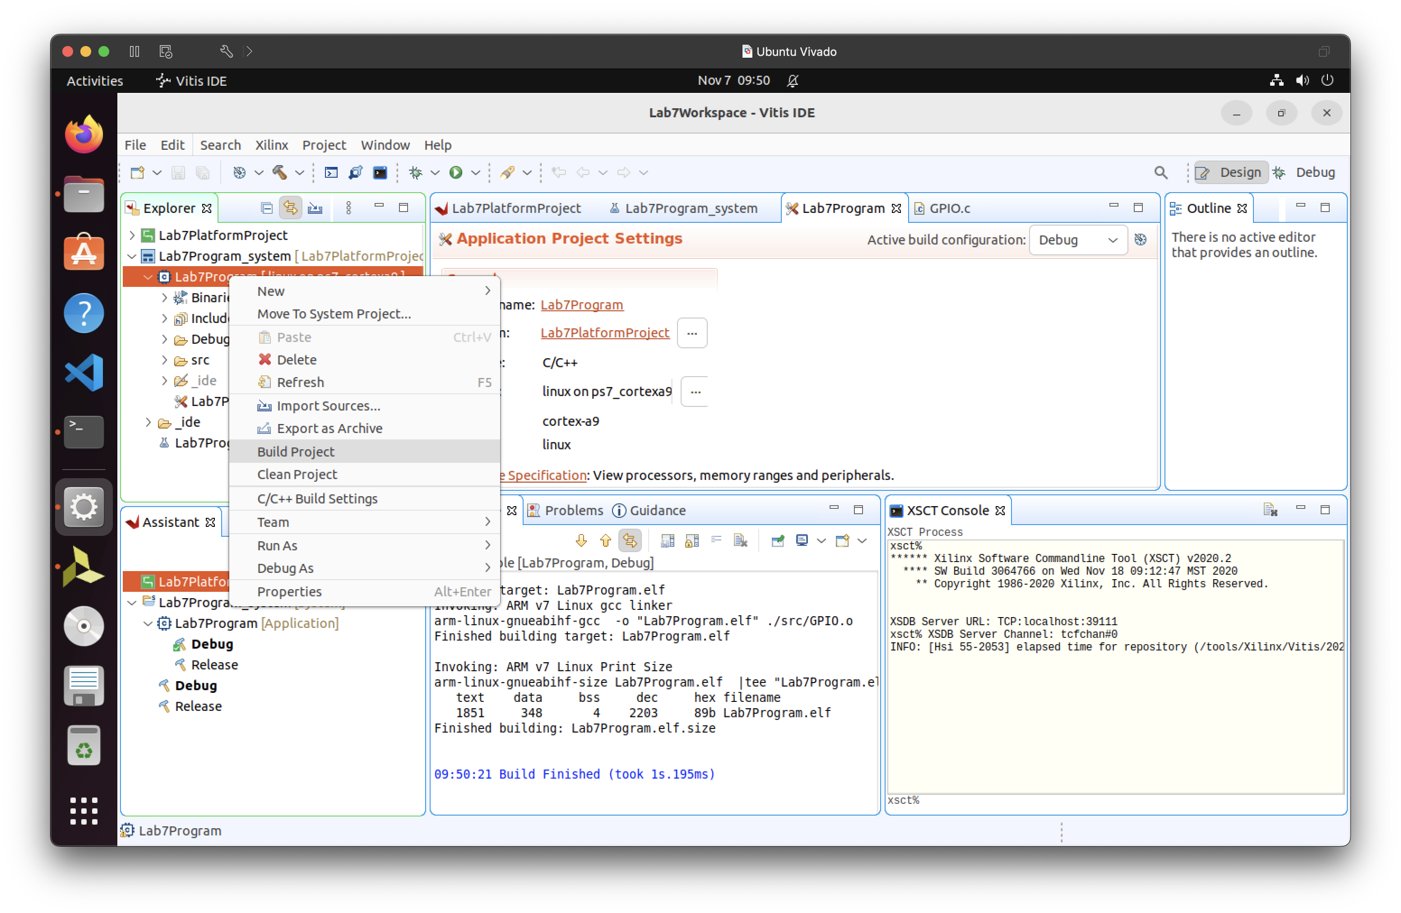

Creating the bit.bin file
- After building the program in Vitis and creating the .elf file

- write_cfgmem -disablebitswap -force -format BIN -size 256 -interface SMAPx32 -checksum -loadbit "up 0x0 /home/zacharymontoya/Desktop/Labs/Lab7/Lab7/project_1.runs/impl_1/design_1_wrapper.bit" -verbose design_1_wrapper.bit.bin

Moving the bit.bin file and .elf file to the zybo linux environment.
- The above command inputted into the tcl command to create the design_1_wrapper.bit.bin command.

  - The design_1_wrapper.bin.bit
    - In windows it outputs to: C:/Users/YourName/AppData/Roaming/Xilinix/Vivado
    - In Linux it outputs to:
/home/YourName
    - It was found just by going ton

- We had a problem at the beginning of the year with the oHostKeyAlgorithms=+ssh-rsa but that flag is not possible to include with the scp command.

- I had to edit the file ~/.ssh/config in the directory /home/zacharymontoya to include the following flags.

  - This file was created with
    - mkdir -p ~/.ssh && chmod 700 ~/.ssh
    - nano ~/.ssh/config
    - chmod 600 ~/.ssh/config
      - This is important so the scp can read the file

  - 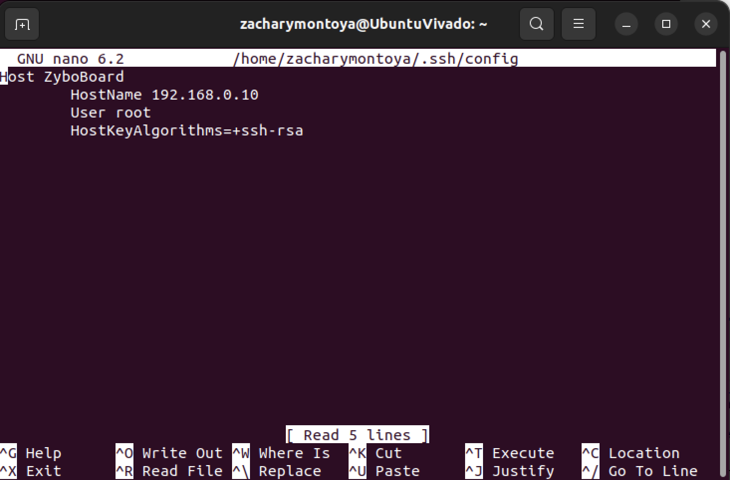

- 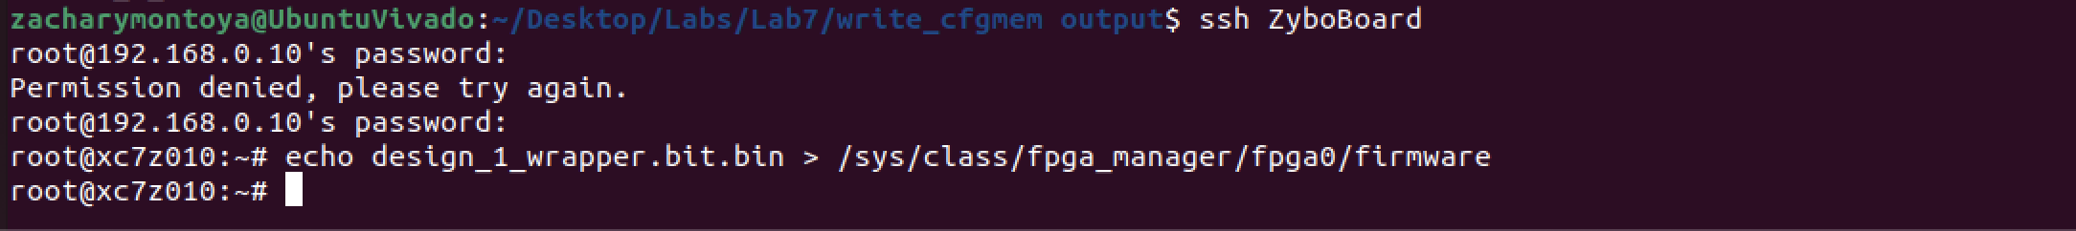

- Copying the elf file over to linux

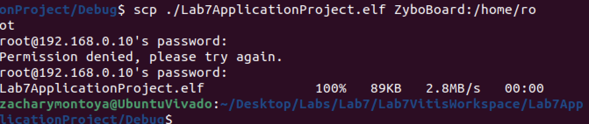

- Running the echo command
- 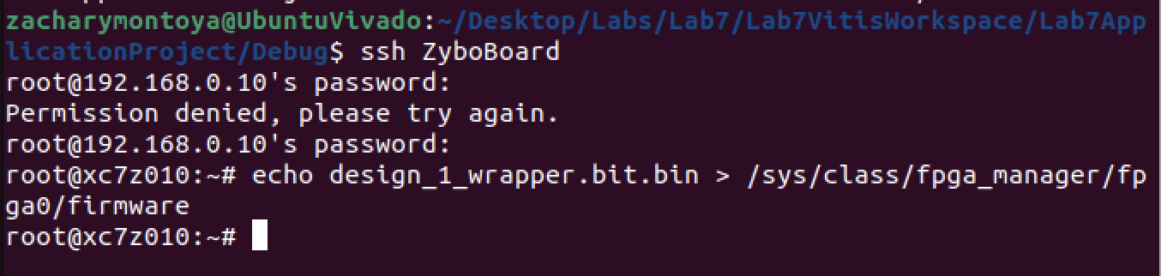

- SUCCESS! Kind of.
- We get the c program to print however there is a problem because the DataRegisters do not match. This is a similar error to Lab 6 multiplier.

- 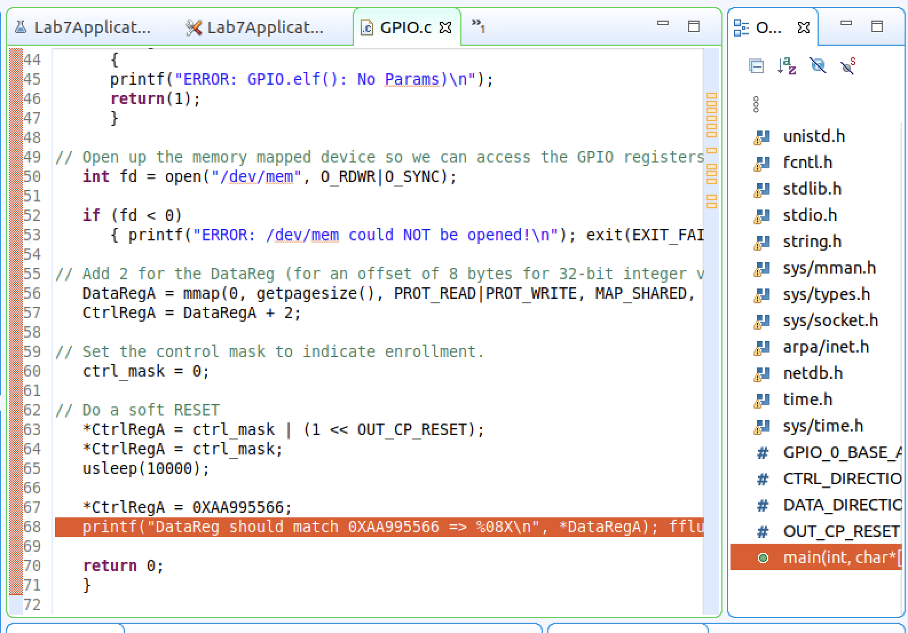

- This matches the .c file

